## Q1

a. Based on the Goldberg Architecture of Virtual machine Model, answer the following questions:  
1. How are resources addressed and abstracted?

resources are addressed and abstracted through the Virtual Machine Monitor (VMM). Resources are addressed under the composed map f o Φ.

2. Contrast between the Φ-map and the f-map.

Φ-map is visible to the operating system software running on the virtual machine. While the f-map which is invisible to that software but which is manipulated by the virtual machine monitor running on the real machine.

Φ-map maps process names into resource names and the f-map maps virtual resource names into real resource names.

The Φ-map -map is the interface seen by an executing program whereas the f-map is the interface seen by the resources.

3. Explain how virtual machine deployment facilitates new advantages that system programmers would achieve.

Virtual machines provide an efficient facsimile of one or more complete computer systems, extending the multiaccess, multi-programming, multi-processing systems of the past decade to be multi-environment systems. They also can provide the following to system programmers: (1)Improving and testing the operating system software. (2) Running hardware diagnostic check-out software. (3) Running different operating systems or versions of an operating system. (4) Running with a virtual configuration which is different from the real system. (5) Measuring operating systems (6) Adding hardware enhancements to a configuration without requiring a recoding of the existing operating system(s). (7) providing a high degree of reliability and security/privacy for those applications which demand it.

4. Identify one operating system that supported a virtual machine as well as three computer systems.

CP-67 is one of the operating systems that supported a virtual machine as well as three computer systems.

5. Interpret/explain the process map/state machine diagram displayed below:

Both diagrams show failures in taking a process name into a real resource name. (a) represents a process name exception. This this case, control is given to the privileged software of the operating system with the same level without VMM knowledge or intervention. (b) is a virtual name fault. It causes control pass to a process in the lower-level virtual machine, without the operating system’s knowledge or intervention. (a) is subject to an f-map, and (b) is subject to a Φ-map.

b. Based on Goldberg’s paper “Formal Requirements for Virtualizable Third Generation Architectures” [2], what is a virtual machine is?

A virtual machine (VM) is a software implementation that simulates the functionality of a physical computer, it can be taken to be an efficient, isolated duplicate of the of the real machine. It provides an environment for the programs which is identical with the original machines and controls of system resources.

c. Based on [2], Formally identify the components of a virtual machine.

The components are: virtual machine, virtual machine monitor, and hardware.

d. Based on [2], what are the elements of Program Status Word?

The elements are: executable storage, processor mode, program counter, and relocation-bounds register

e. Based on [2], what is a Virtual Machine Monitor?

A virtual machine monitor is a particular piece of control program, which allows multiple operating systems to share the same physical resources independently and securely so they can run on a physical hardware device concurrently.

f. Based on [2], list the properties of virtual machines.

There are three properties: the efficiency property, the resource control property, and the equivalence property

g. Based on [2], what is Recursive Virtualization?

It is a capability that a virtual machine can run under itself a copy of the VMM and that copy also exhibit all the properties of a VMM. The nested VMs can run their own operating systems and as if they were running on physical hardware.

## Q2

1.1 Does Hyper-V support type 1 virtualization or type 2 virtualization?

Type 1

1.2 The paper [Timmerman et al] identifies performance metrics used for evaluation tests purposes, list those metrics.

(1) Clock tick processing duration. (2) Thread switch latency between threads of same priority,

1.3 What approaches/modes does Hyper-V support.

Full virtualization (FV)/Hardware emulation and Para-virtualization (PV)

1.4 Explain how would paravirtualization differ from hardware emulation approaches.

In the clock-tick processing duration test results, enlightened VM usually performs less time than Emulated VM. enlightened (paravirtualized) VMs perform significantly better than hardware-emulated VMs, with performance improvements varying based on the scenario.

1.5 How does Enlightened partition differ from Unenlighted partition?

Enlightened partitions have a virtual view of resources and utilize virtual devices. Requests to these devices are redirected via the VMBus to the parent partition that manages these requests, leveraging Virtualization Service Provider (VSP) and Virtualization Service Client (VSC) for device access and advanced features, respectively. However, Unenlightened partitions lack these integration components and VSCs, relying instead on emulation for device interaction.

1.6 What is the core requirement for Enlighted virtualization?

The core requirement for enlightened virtualization in Microsoft Hyper-V is the addition of special drivers to the virtual machine (VM). These drivers provide advanced features and performance enhancements for the VMs operating in an enlightened mode, which leverages paravirtualization techniques.

1.7 What is the core requirement for Emulated Virtualization?

The core requirement for Emulated Virtualization is the integration of special drivers within the virtual machines to provide advanced features and performance improvements for virtual machines.

1.8 what is failover clustering and identify why would recommend its deployment?

It is a kind of supporting components. Failover clustering involves connecting multiple servers in such a way that if one fails, another can immediately take over its tasks to minimize downtime and ensure continuous service availability. It is recommended because it improves the systems’ resilience and ensures that services remain available even in the event of hardware or software failures.

1.9 An associated software to Hyper-V is Virtual Machine Manager; explain what functionalities the software provides. Identify its capacity limits in terms of number of physical hosts, number of virtual machines, number of services, number of clouds, roles classifications, and number of logical networks.

The functionalities include management of datacenter components, provisioning and management of resources for virtual machines and services, and deployment of virtual machines and services to private clouds. As for capacity limits tested for System Center Virtual Machine Manager, it supports up to 1,000 physical hosts, 25,000 VMs, 1,000 services, 1,000 user roles, 20 clouds, 2,000 virtual networks, and 20 logical networks. These limits are influenced by factors like hardware configuration, network topology, and others.

1.10 VMware is one of the leading virtualization product providers; VMware HCI (Hyperconverged infrastructure) is a software-defined, unified system that combines all the elements of a traditional data center: storage, compute, networking and management. Identify why would your recommend such a scheme to your organization, and identify four Vmware products that would facilitates the deployment of and HCI system

HCI brings several strategic advantages, including simplification of data center management, enhanced scalability, and operational efficiencies. VMware's HCI integrates computing, storage, networking, and virtualization resources into a single, software-defined platform, offering a transformative solution for modern enterprises. This consolidation addresses the challenges of traditional IT infrastructure by reducing operational complexities, lowering costs, and improving scalability, making it an ideal foundation for hybrid and cloud-native strategies.

The four Vmware products are: VMware vSphere, VMware vSAN, VMware NSX Data Center, VMware vRealize Suite.

## Q3

1

2

3

4

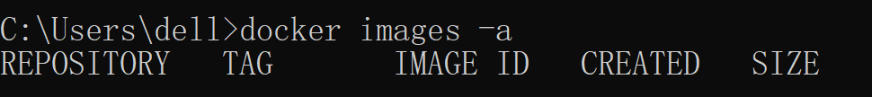

5

6

7

8

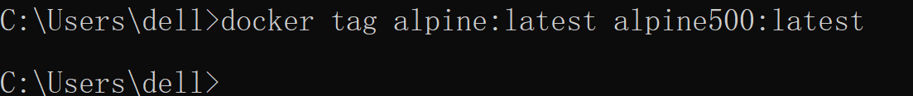

9

10.a



10.b



10.c

11

12



13

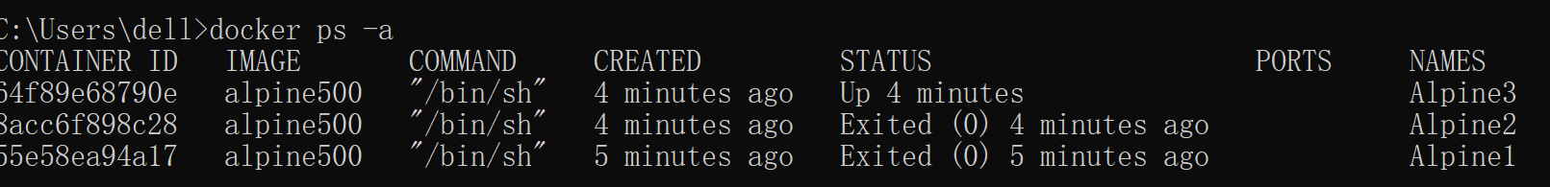

14



15

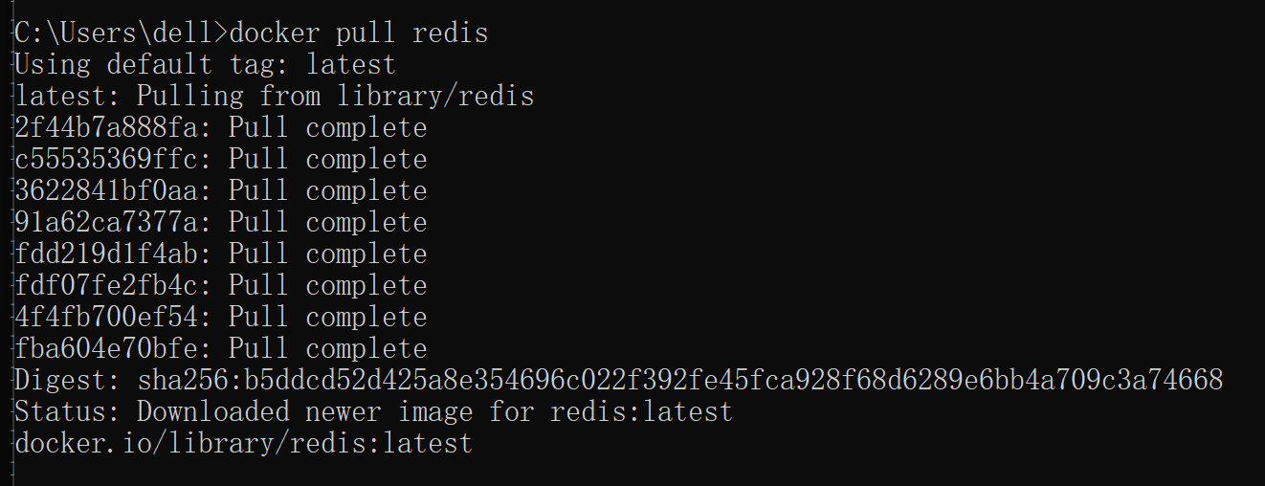

16

17



18

19

1. It was created 3 minutes ago
2. Execute docker exec -it Alpine3 /bin/sh

20



21

## Q4

1

2

3

4

5

6

7



8

9

10

11

12

13



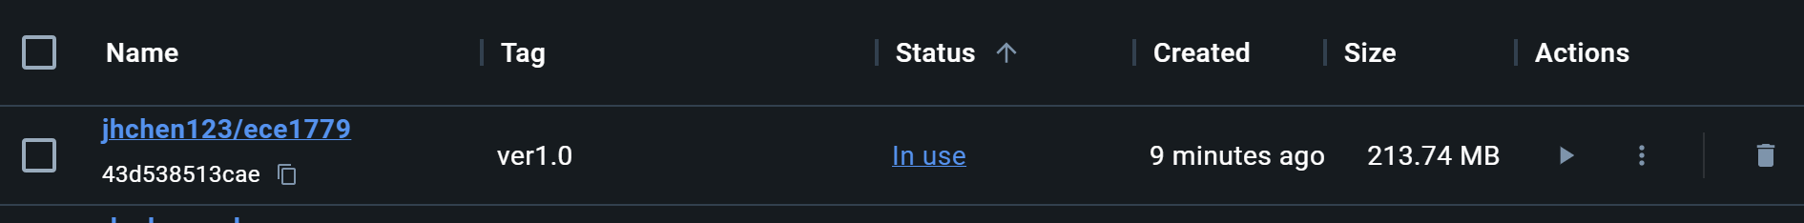

14



## Q5

1

2

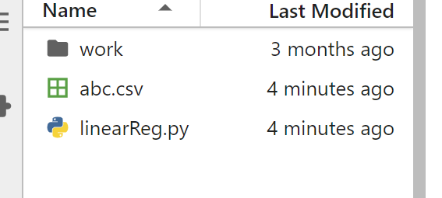

3

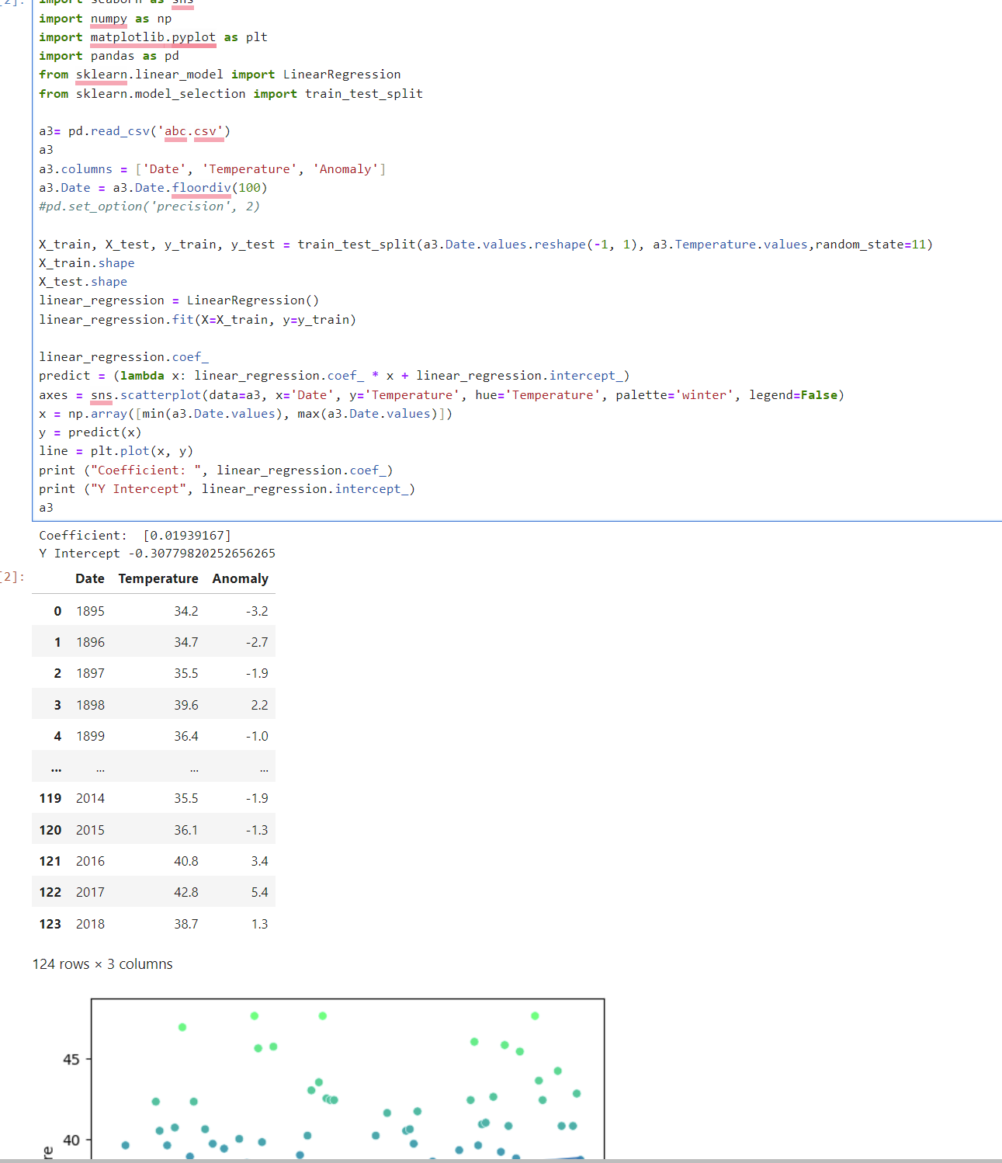

4

Coefficient: [0.01939167]

Y Intercept -0.30779820252656265

5

## Q6

3

A

B

C

D

